Ch. 7 L. 1 Notes 5-5.2 Summarize the motion of an object in terms of position, direction, and speed.5-5.5 Use a graph to illustrate the motion of an object.

Position: where an object is relative to another object (the ______________ point) Position is described as above, below, beside, etc. and the ________ from that other object. Example: The hot air balloon’s position is 500 meters above the ground (reference point).
Distance: the ________________ from the reference point. Distance changes when the object ________________.
Direction of motion is the ___________ that an object is moving and can be described with the terms “north”, “south”, “east”, “west,” “right”, “left,” “forward,” or “toward” relative to another object, or “up”, or “down” relative to ___________________.
Speed: A measure of how fast an object is moving.
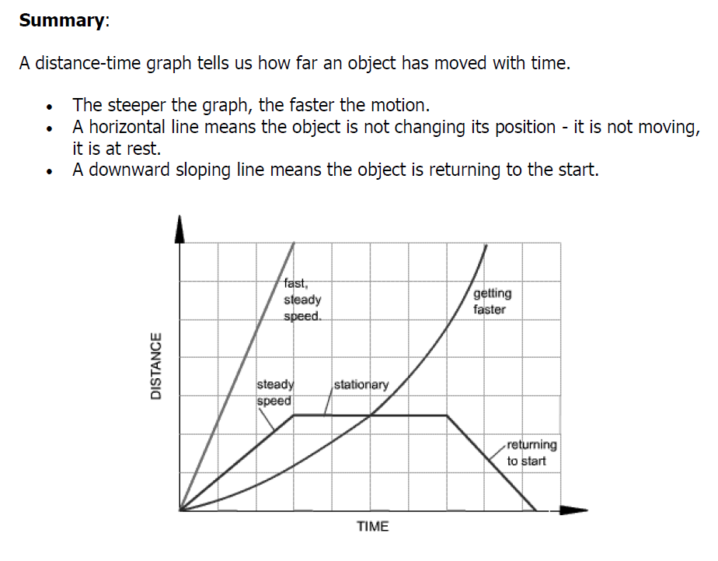
D = dependent variable (D is also for ___________________)
R = ___________________ variable
Y = y axis ( the vertical axis)
M = _______________________ variable
I = independent variable
X = x axis (the horizontal axis)
Ch. 7 L. 1 Notes 5-5.2 Summarize the motion of an object in terms of position, direction, and speed.5-5.5 Use a graph to illustrate the motion of an object.

Position: where an object is relative to another object (the ______________ point) Position is described as above, below, beside, etc. and the ________ from that other object. Example: The hot air balloon’s position is 500 meters above the ground (reference point).
Distance: the ________________ from the reference point. Distance changes when the object ________________.
Direction of motion is the ___________ that an object is moving and can be described with the terms “north”, “south”, “east”, “west,” “right”, “left,” “forward,” or “toward” relative to another object, or “up”, or “down” relative to ___________________.
Speed: A measure of how fast an object is moving.
D = dependent variable (D is also for ___________________)
R = ___________________ variable
Y = y axis ( the vertical axis)
M = _______________________ variable
I = independent variable
X = x axis (the horizontal axis)
Ch. 7 L. 1 Notes 5-5.2 Summarize the motion of an object in terms of position, direction, and speed.5-5.5 Use a graph to illustrate the motion of an object.

Position: where an object is relative to another object (the reference point) Position is described as above, below, beside, etc. and the distance from that other object. Example: The hot air balloon’s position is 500 meters above the ground (reference point).
Distance: the length from the reference point. Distance changes when the object moves.
Direction of motion is the path that an object is moving and can be described with the terms “north”, “south”, “east”, “west,” “right”, “left,” “forward,” or “toward” relative to another object, or “up”, or “down” relative to Earth.
Speed: A measure of how fast an object is moving.
D = dependent variable (D is also for Distance)
R = responding variable
Y = y axis ( the vertical axis)
M = manipulated variable
I = independent variable
X = x axis (the horizontal axis)

